**ASSIGNMENT 1**

#1. **Report view page which appears when power desktop starts**

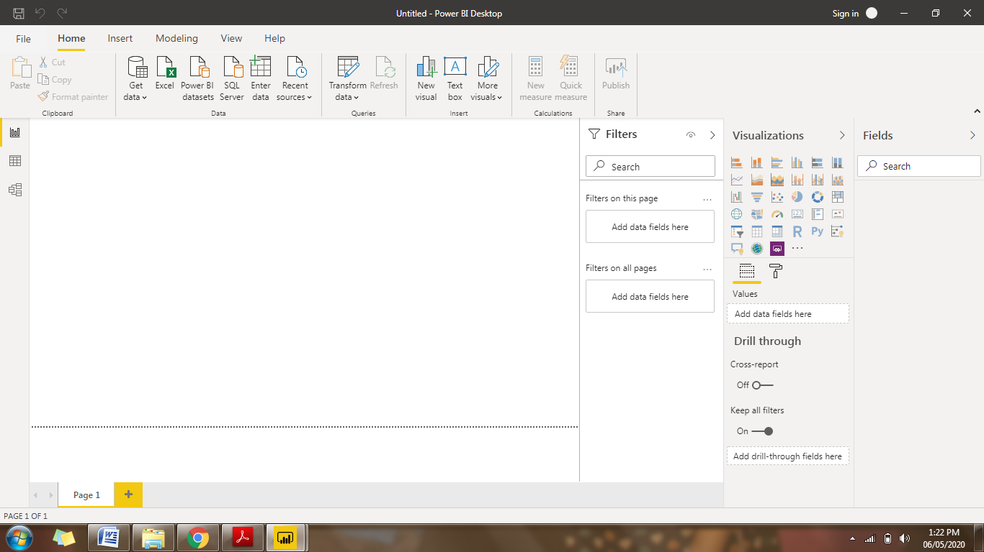

#2.

(i)**Report View**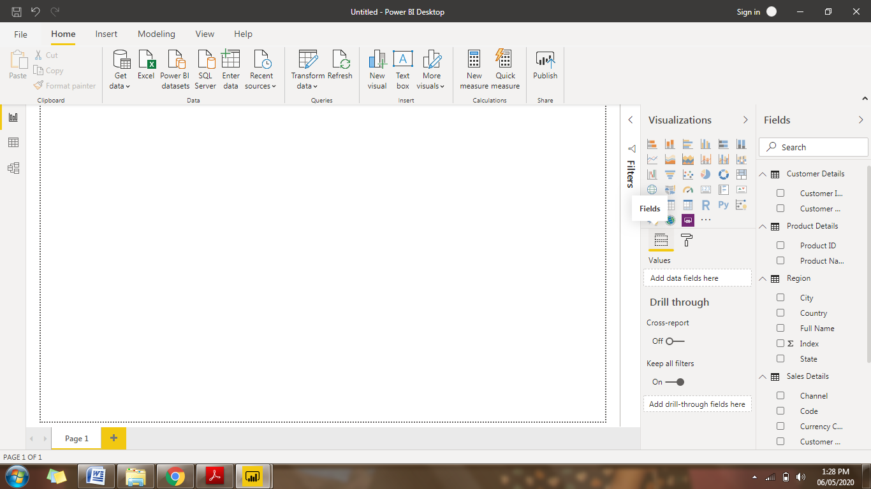

(ii)**Data View**

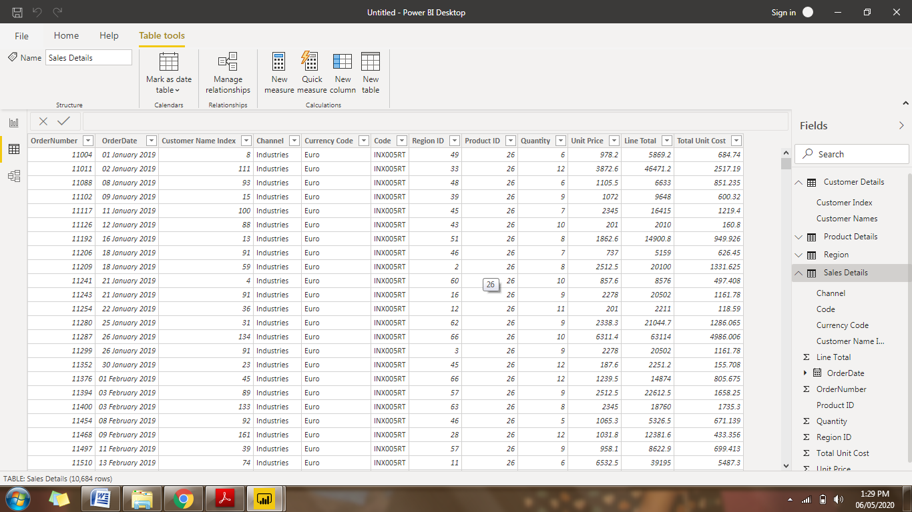

(iii) **Model View**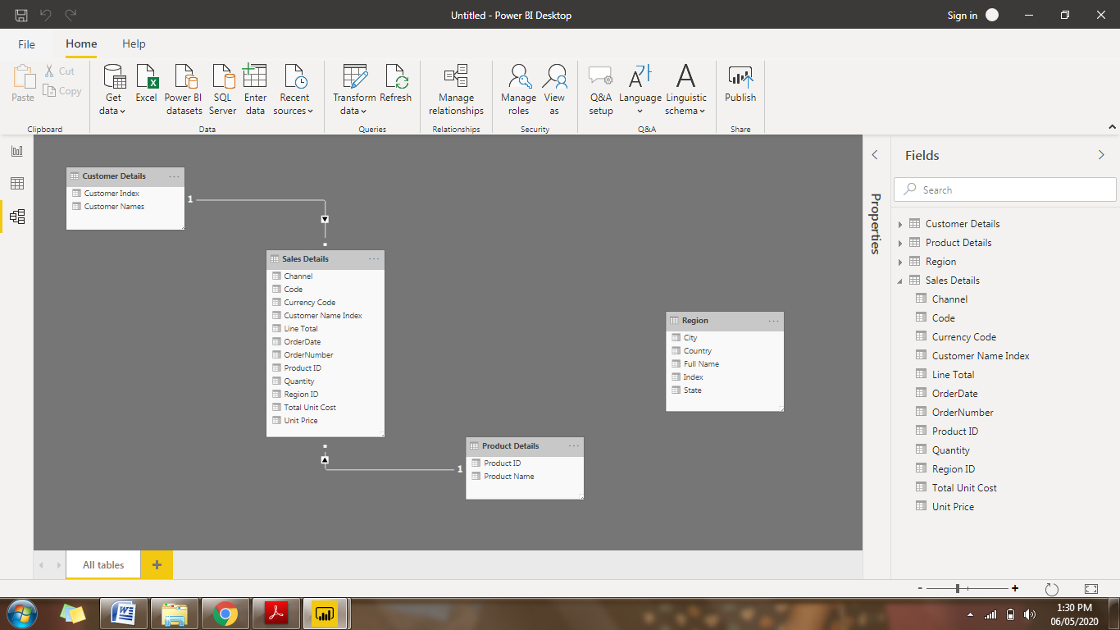

(iv) **Power Query Editor**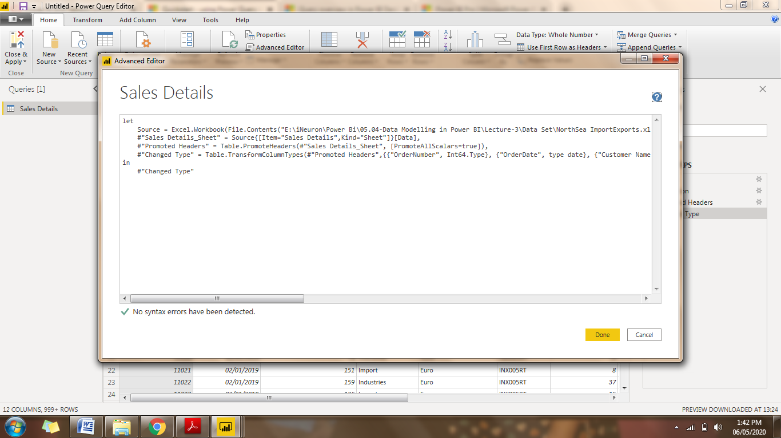

(v) **Advanced editor** 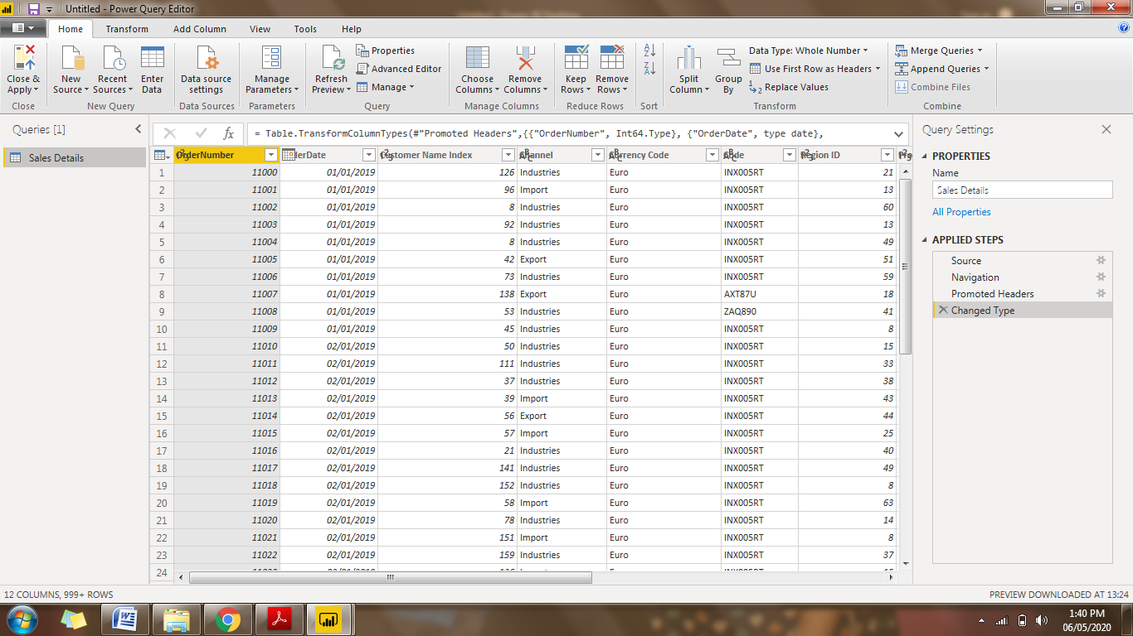

# 3

(i) **Power BI Desktop**

Power BI Desktop is a free application, you install on your local computer that lets you connect to, transform, and visualize your data. With Power BI Desktop, you can connect to multiple different sources of data, and combine them (often called modelling) into a data model. This data model lets you build visuals, and collections of visuals you can share as reports, with other people inside your organization. Most users who work on business intelligence projects use Power BI Desktop to create reports, and then use the Power BI service to share their reports with others.

Price : Free

(ii) **Power BI Pro**

Power BI Pro is an individual user license that lets users read and interact with reports and dashboards that others have published to the Power BI service. Users with this license type can share content and collaborate with other Power BI Pro users. Only Power BI Pro users can publish or share content with other users or consume content that's created by others, unless a Power BI Premium capacity hosts that content.

Price : $9.99/user/month

758.16 INR/user/month

(iii) **Power BI Premium**

You can use Power BI Premium to get dedicated and enhanced resources for your organization, so users in your organization can use the Power BI service with better performance and responsiveness. For example, with a Power BI Premium subscription, you and your organization's users get access to:

* Greater scale and performance
* Flexibility to license by capacity
* Unify self-service and enterprise BI
* Extend on-premises BI with Power BI Report Server
* Support for data residency by region (Multi-Geo)
* Share data with anyone without purchasing a per-user license

Price : $4,995 a month per dedicated cloud compute and storage resource

75,520.29 INR a month per dedicated cloud compute and storage resource